David Winton Written Analysis for Tableau “City Bike” Homework 4/15/2020

The following analysis was performed to provide a ridership profile of New York City’s City Bike system for the 2019 rental season. This was done in order to create a baseline comparison for what impact the COVID-19 Pandemic will have on the 2020 season.

1. Data was pulled from March through October 2019, and compared to data from previous years, indicating a distinct bike rental season between April and September for a total of **12.9 million rides** *(Total gleaned from number of riders under Gender category).*

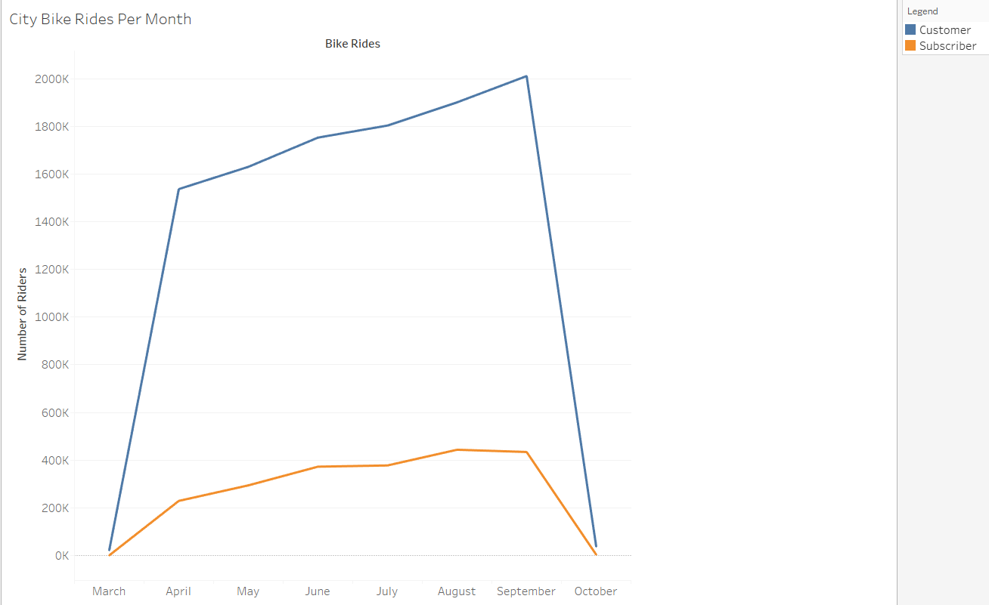 

Rentals climbed steadily from the first week of April *(47,577 Subscribers and 361,729 Customers)* to its peak in the second week of September *(119,050 Subscribers and 501,845 Customers).*

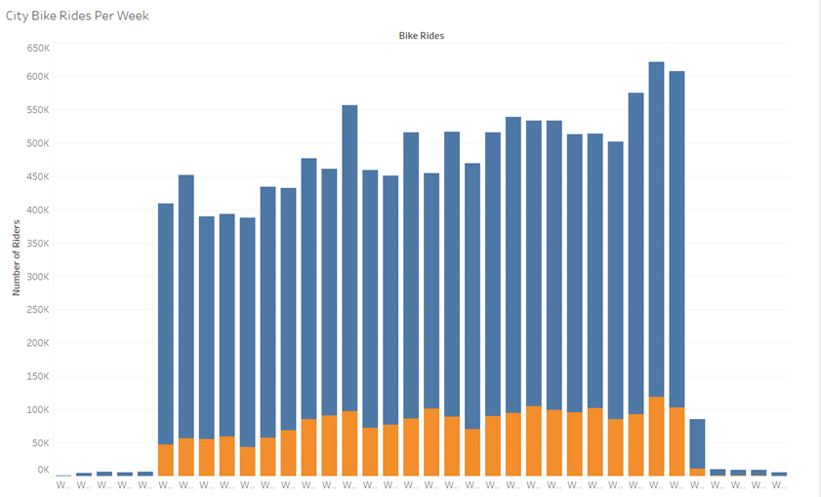

1. Rider demographics indicate that males *(8,543,027 riders)* are the most frequent City Bike users, followed by **3,173,903 female riders** and **1,136,144 undeclared riders** *(Totaling 12.9 million riders)*.

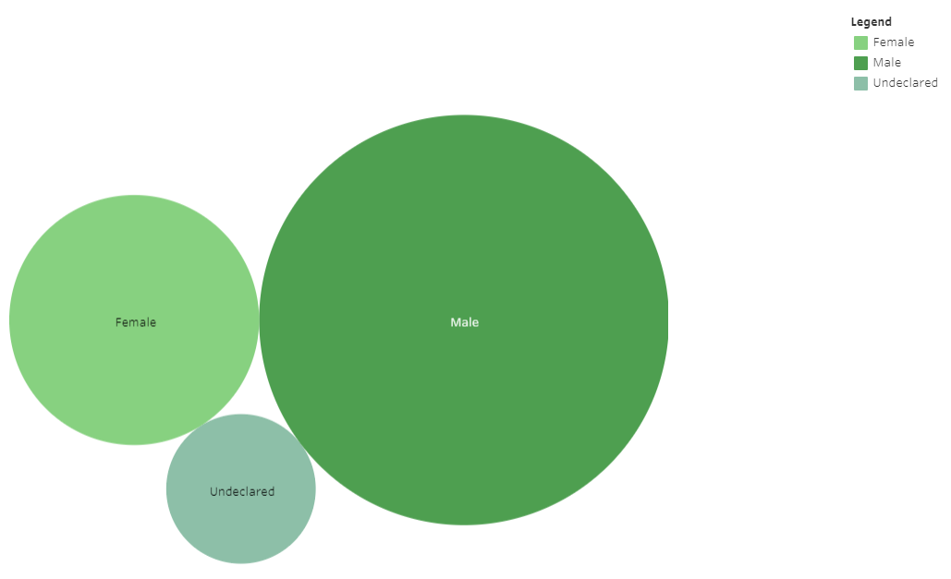 

When examined by age, the largest group of riders are 21 to 40 years old. However, there are two interesting peaks at 30-year-olds and 50-year-olds. It appears that most 30-year-olds are Customers, totaling 469,683 riders, while 50-year-olds are subscribers accounted for 937,828 riders. It could be hypothesized that City Bike subscriptions may be popular gifts for New Yorkers turning 50.

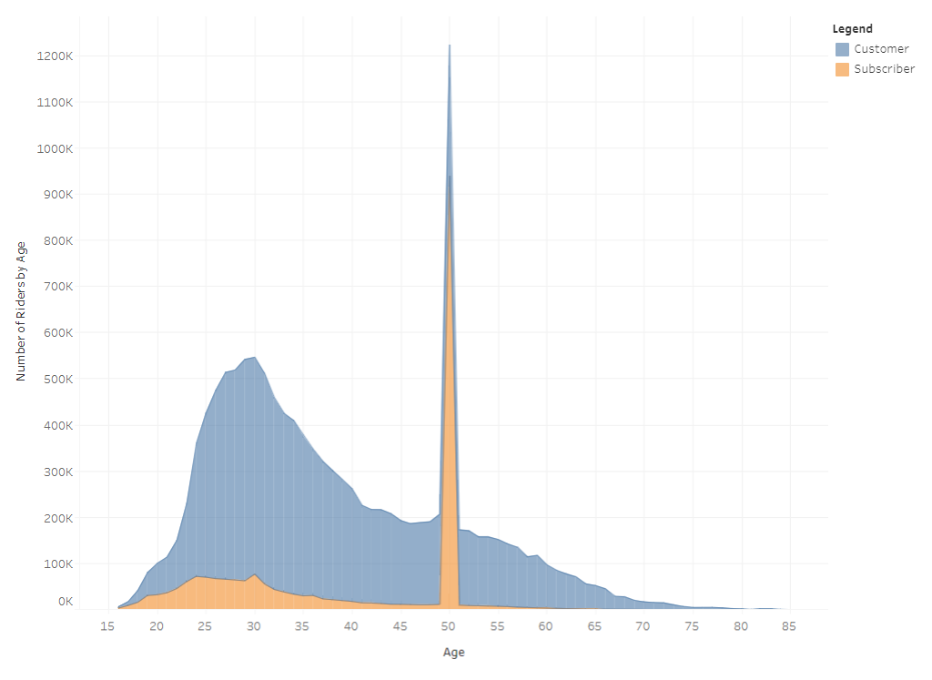

Summary

Based on the above data, it appears that the typical City Bike rider for 2019 was a rental customer aged 21 to 40 years old who wanted to tour the city during warmer weather.

In addition, it appears that these riders were also weekend, holiday or stay-cation tourists due to the Central and Lower Manhattan stations showing the most activity, indicated by the varying green shades on the City Bike Station Map. Stations away from the main tourist areas, in Uptown Manhattan, east Brooklyn and Queens, the North Bronx and New Jersey, had lower numbers, which are indicated by the varying shades of blue.

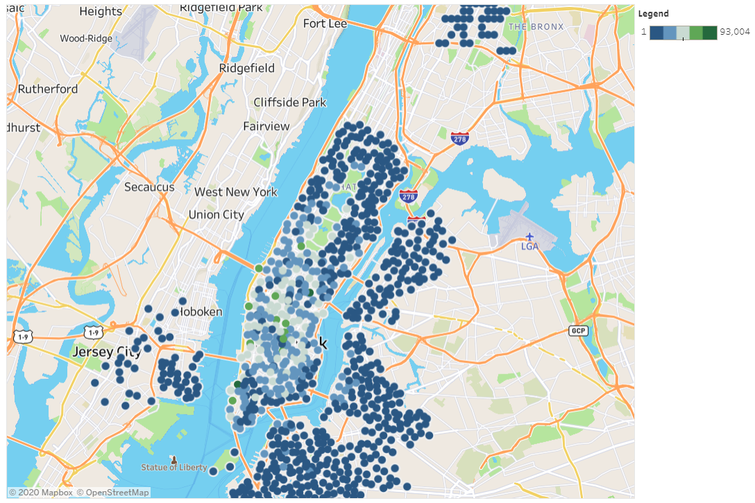

City Bike Rider Demographics indicate that a marketing strategy is needed to attract more female riders. Also, further exploration is needed for the spike in 50-year-old Subscribers in the City Bike Rider Demographics to see if a market group exists for the phenomenon.

Once the COVID-19 pandemic impact is determined on the 2020 season, these 2019 ridership observations can help develop targeted campaigns to re-attract City Bike riders for the 2021 season.